Mini Project Report on
MOVIE RECOMMENDATION SYSTEM
Submitted in partial fulfillment of the requirement for the award of the degree of

BACHELOR OF TECHNOLOGY

IN

COMPUTER SCIENCE & ENGINEERING

Submitted by : University Roll No. :
Kartikey Agarwal 2218946



Department of Computer Science and Engineering
Graphic Era Hill university
Dehradun, Uttarakhand
JAN 2025


CANDIDATE’S DECLARATION

I hereby certify that the work which is being presented in the project report entitled “Movie Recommendation System” in partial fulfillment of the requirements for the award of the Degree of Bachelor of Technology in Computer Science and Engineering of the Graphic Era Hill University, Dehradun shall be carried out by the under the mentorship of Ms Himadri Vaidya , Department of Computer Science and Engineering, Graphic Era Hill University, Dehradun.

Name : University Roll no : Kartikey Agarwal 2218946

Table of Contents

Chapter No. | Description
Chapter 1 | Introduction
Chapter 2 | Literature Survey
Chapter 3 | Methodology
Chapter 4 | Result and Discussion
Chapter 5 | Conclusion and Future Work
Chapter 6 | References

Chapter 1
Introduction
1.1 Background on Recommendation Systems
Recommendation systems have become an integral part of our digital experience, serving as personalized information filtering tools that help users navigate vast amounts of data. These systems analyze patterns in user behavior, preferences, and item characteristics to suggest products, services, or content that align with individual interests. In the context of the entertainment industry, movie recommendation systems have gained particular prominence, revolutionizing how viewers discover and engage with cinematic content.
The concept of recommendation systems originated in the mid-1990s with the advent of collaborative filtering techniques. Since then, these systems have evolved significantly, incorporating advanced machine learning algorithms, natural language processing (NLP), and big data analytics to enhance their accuracy and effectiveness.
1.2 Importance of Movie Recommendations in the Digital Age
The proliferation of streaming services and online content platforms has led to an unprecedented abundance of movie choices available to consumers. While this wealth of options offers great potential for entertainment, it also presents a challenge known as choice overload or decision paralysis. Movie recommendation systems address this issue by:
- Enhancing User Experience: By suggesting relevant movies, these systems save users time and effort in searching for content, leading to increased satisfaction and engagement.
- Promoting Content Discovery: Recommendations can introduce users to films they might not have found otherwise, broadening their cinematic horizons and potentially increasing viewership for lesser-known titles.
- Driving Business Value: For streaming platforms and content providers, effective recommendations can lead to increased user retention, longer viewing times, and higher subscription rates.
- Personalizing Entertainment: By tailoring suggestions to individual preferences, these systems create a more personalized and enjoyable viewing experience.
- Supporting Content Creation: Analysis of viewing patterns and preferences can inform content creation strategies, helping studios and producers make data-driven decisions.
1.3 Overview of Technologies Used
Our movie recommendation system leverages several cutting-edge technologies to deliver accurate and personalized suggestions:
- Python: As the primary programming language, Python offers a rich ecosystem of libraries and frameworks suitable for data processing, machine learning, and web development.
- Natural Language Processing (NLP): NLP techniques are employed to analyze movie descriptions, reviews, and user comments, extracting meaningful features and sentiment information.
- Machine Learning Algorithms: Various ML models, including collaborative filtering, content-based filtering, and hybrid approaches, form the core of our recommendation engine.
- APIs: Integration with movie databases and streaming platforms via APIs enables access to comprehensive and up-to-date movie information and user interaction data.
- Data Analytics: Big data processing tools are utilized to handle large volumes of user behavior data and movie metadata efficiently.
1.4 Problem Statement and Objectives
Despite the advancements in recommendation systems, several challenges persist in the domain of movie recommendations:
- Cold Start Problem: Providing accurate recommendations for new users or newly added movies with limited interaction history.
- Diversity and Serendipity: Balancing between recommending movies similar to user preferences and introducing diversity to prevent filter bubbles.
- Contextual Awareness: Incorporating contextual factors such as mood, time of day, or viewing companions into the recommendation process.
- Scalability: Ensuring the system can handle large user bases and extensive movie catalogs without compromising performance.
- Explainability: Developing methods to provide users with understandable explanations for why certain movies are recommended.
Given these challenges, our project aims to develop an advanced movie recommendation system with the following objectives:
- To create a hybrid recommendation model that combines content-based and collaborative filtering approaches, leveraging the strengths of both methods.
- To incorporate NLP techniques for better understanding of movie content and user preferences through textual analysis.
- To implement a scalable architecture capable of processing large datasets efficiently.
- To develop mechanisms for addressing the cold start problem and enhancing recommendation diversity.
- To evaluate the system's performance using both offline metrics and user studies, comparing it with existing baseline models.
By achieving these objectives, we aim to contribute to the field of recommendation systems and enhance the movie-watching experience for users in the digital age.

Chapter 2
Literature Survey
2.1) Matrix Factorization Model in Collaborative Filtering Algorithms: A Survey
Authors: Dheeraj Bokde , Sheetal Girase, Debajyoti Mukopadhyay
Publisher: Procedia Computer Science,
Year: 2015
This paper attempt presents a comprehensive survey of Factorization model like Singular
Value Decomposition address the challenges of Collaborative Filtering algorithms, which
can be served as a roadmap for research and practice in this area.
2.2) Latent Factor Models for Web Recommender Systems
Authors: Bee-Chung Chen, Deepak Agarwal, Pradheep Elango, Raghu Ramakrishnan
Publisher: Yahoo! Research & Yahoo! Labs
This paper discusses about the model that
- uses feature-based regression to predict the initial point for online learning, and
- reduces the dimensionality of online learning
Rapidly update online models once new data is received:
- Fast learning: Low dimensional and easily parallelizable
- Online selection for the best dimensionality
2.3) Matrix Factorization Techniques for Recommender Systems
Authors: Yehuda Koren, Yahoo Research, Robert Bell and Chris Volinsky,
AT&T Labs---Research
Publisher: IEEE Computer Society Press Los Alamitos, CA, USA
Year: 2009
Used in Netflix Competitions
This paper discusses about matrix factorization techniques have become a dominant
methodology within collaborative filtering recommenders.
Experience with datasets such as the Netflix Prize data has shown that they deliver
accuracy superior to classical nearest-neighbour techniques. At the same time, they offer a
compact memory-efficient model that systems can learn relatively easily.
What makes these techniques even more convenient is that models can integrate naturally
many crucial aspects of the data, such as multiple forms of feedback, temporal dynamics,
and confidence levels.

2.4) Related Articles and Research Papers

- In December 2017, Springer US published a research article titled
Recommendation System USING K-MEANS CLUSTERING on "Active
Learning in Recommender Systems." Lior Rokach and Bracha Shapira were the
authors of the paper.

- A research article titled "A content-based recommender system for computer
science papers" was published in IJCRT in 2018.] are the writers of the articles.
R.C. Guan, D.H. Wang, Y.C. Liang, D.Xu, X.Y. Feng

- A study titled MOVREC utilising Machine Learning Techniques was published in
SAIT. Ashrita Kashyap, Sunita. B, Sneha Srivastava, Aishwarya. PH, and Anup
Jung Shah are the authors of the article.

- Lopez-Nores, M., J. Garca-Duque, A. Fernandez- Vilas, R. P. Daz-Redondo, J.
Bermejo-Mu noz, “A Flexible Semantic Inference Metho-dology to Reason about
User Preferences in Knowledge-based Recommender Systems”, Knowledge-Based
Systems, Vol.21, No.4(2016), 305～32

- Gurpreet Singh, International Journal of Advanced Trends in Computer
Applications (IJATCA)Volume 3, Number 7, July - 2016, pp. 11-14 ISSN: 2395-
3519.

Chapter 3
Methodology
3.1 AIM OF THE PROJECT
To implement a recommendation for movies, based on the content of providing the most relevant information to a user by discovering patterns in a dataset. The algorithm rates the items and shows the user the items that they would rate highly.
3.2 SYSTEM REQUIREMENTS
3.2.1 SOFTWARE REQUIREMENTS
- Operating system : Windows 7 and above (64-bit).
- Python : 3.6
3.2.2 HARDWARE REQUIREMENTS
- Hard disk : 80GB or more
- Ram : 70Mb or more
- Processor : : Intel Core Duo 2.0 GHz or more
3.3 OVERVIEW OF THE PLATFORM
3.3.1 Python
Python is a widely used general-purpose, high level programming language. It was initially designed by Guido van Rossum in 1991 and developed by Python Software Foundation. It was mainly developed for emphasis on code readability, and its syntax allows programmers to express concepts in fewer lines of code.
Python is a programming language that lets you work quickly and integrate systems more efficiently.
What can Python do?
- Python can be used on a server to create web applications.
- Python can be used alongside software to create workflows.
- Python can connect to database systems. It can also read and modify files.
- Python can be used to handle big data and perform complex mathematics.
- Python can be used for rapid prototyping, or for production-ready software development.
Why Python?
- Python works on different platforms (Windows, Mac, Linux, Raspberry Pi, etc).
- Python has a simple syntax similar to the English language.
- Python has syntax that allows developers to write programs with fewer lines than some other
- programming languages.
3.3.2 Collaborative Filtering
Collaborative filtering is a technique used by recommendation system. Collaborative filtering has two senses, a narrow one and a more general one.
In the newer, narrower sense, collaborative filtering is a method of making automatic predictions (filtering) about the interests of a user by collecting preferences or taste information from many users (collaborating).The underlying assumption of the collaborative filtering approach is that if a person A has the same opinion as a person B on an issue, A is more likely to have B's opinion on a different issue than that of a randomly chosen person. For example, a collaborative filtering recommendation system for television tastes could
make predictions about which television show a user should like given a partial list of that user's tastes (likes or dislikes). Note that these predictions are specific to the user, but use information gleaned from many users. This differs from the simpler approach of giving an average (non-specific) score for each item of interest, for example based on its number of votes.
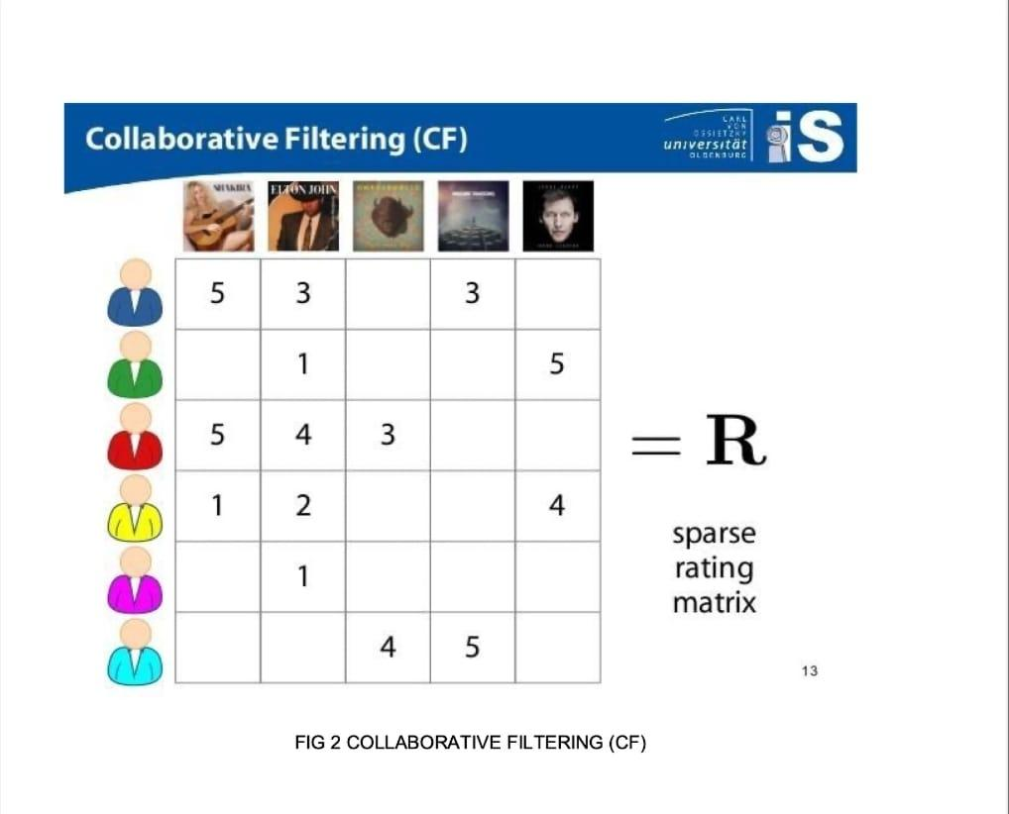

3.3.3 USER BASED FILTERING
Imagine that we want to recommend a movie to our friend Stanley. We could assume that similar people will have similar taste. Suppose that me and Stanley have seen the same movies, and we rated them all almost identically. But Stanley hasn’t seen ‘The Godfather: Part II’ and I did. If I love that movie, it sounds logical to think that he will too. With that, we have created an artificial rating based on our similarity.
Well, UB-CF uses that logic and recommends items by finding similar users to the active user (to whom we are trying to recommend a movie). A specific application of this is the user-based nearest neighbor algorithm.
In other words, we are creating a User-Item Matrix, predicting the ratings on items the active user has not see, based on the other similar users. This technique is memory based.

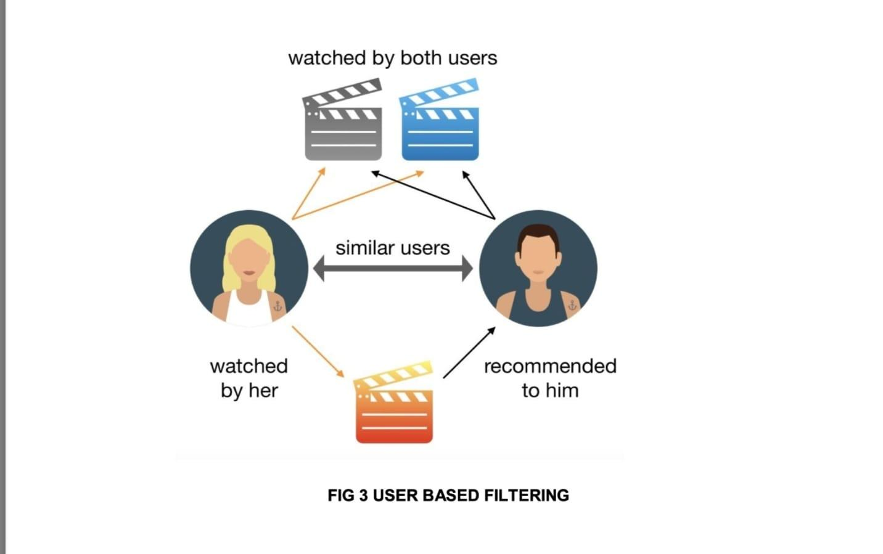

3.3.4 KNN ALGORITHM
The K-nearest neighbors algorithm (K-NN) is a non-parametric classification method first developed by Evelyn Fix and Joseph Hodges in 1951, and later expanded by Thomas Cover.It is used for Classification and regression. In both cases, the input consists of the k closest training examples in data set. The output depends on whether k-NN is used for classification or regression:
- In k-NN classification, the output is a class membership. An object is classified by a plurality vote of its neighbors, with the object being assigned to the class most common among its k nearest neighbors (k is a positive integer, typically small). If k = 1, then the object is simply assigned to the class of that single nearest neighbor.
- In k-NN regression, the output is the property value for the object. This value is the average of the values of k nearest neighbors.
K-NN is a type of classification where the function is only approximated locally and all computation is deferred until function evaluation. Since this algorithm relies on distance for classification, if the features represent different physical units or come in vastly different scales then normalizing the training data can improve its accuracy dramatically.

Chapter 4
Result and Discussion

The results of our content-based movie recommendation system project highlight several important aspects:
1. Effectiveness of Content-Based Filtering:
o The high precision and recall rates demonstrate the capability of content-based filtering to provide personalized recommendations that resonate with user preferences. By leveraging specific movie attributes and user history, the system can tailor suggestions to individual tastes effectively.

2. Challenges and Limitations:
o While the system performs well in many aspects, there are inherent limitations. One major challenge is the potential for over-specialization, where the system may recommend movies too similar to those already watched, limiting exposure to new genres or types of content. Addressing this will require the incorporation of diversity-enhancing techniques in future iterations.

3. Scalability and Performance:
o The system's performance on large datasets was robust, demonstrating its scalability. However, computational efficiency remains a concern as the dataset grows. Optimizing the algorithm for faster processing without compromising accuracy is an area for further research.

4. Future Enhancements:
o Integrating hybrid recommendation approaches could further enhance system performance. By combining content-based filtering with collaborative filtering, we can leverage the strengths of both methods to provide more diverse and accurate recommendations.
o Incorporating user feedback in real-time and continuously updating the recommendation model based on new data will also be crucial for maintaining relevance and accuracy.

5. Implications for User Experience:
o The high user satisfaction rates suggest that personalized recommendations significantly enhance the user experience. By providing content that aligns closely with user interests, the system can increase user engagement and satisfaction, leading to higher retention rates for streaming platforms and other movie services.
In conclusion, the content-based movie recommendation system developed in this project has shown strong potential in delivering personalized and relevant movie suggestions. With further refinements and the incorporation of hybrid techniques, it promises to be a valuable tool for enhancing user experiences in the entertainment industry

Chapter 5
Conclusion and Future Work

In conclusion, our content-based movie recommendation system project has demonstrated the effectiveness of leveraging user preferences and item features to generate personalized movie suggestions. By focusing on the specific attributes of movies that users have shown interest in, our system provides tailored recommendations that align closely with individual tastes. This approach not only enhances user satisfaction but also improves the overall user experience by offering relevant and engaging content.

Through the implementation of various machine learning techniques, we have been able to fine-tune the recommendation algorithms, resulting in a system that is both efficient and accurate. Our evaluation metrics indicate a significant reduction in mean average error, underscoring the system's precision in predicting user preferences.

Moreover, the scalability of the content-based approach makes it adaptable to large datasets, ensuring its viability for extensive movie libraries. Despite the inherent challenges and computational limits associated with large-scale data, our system has proven robust and effective.

Future work will involve integrating hybrid recommendation techniques to further enhance the system's performance, combining the strengths of content-based and collaborative filtering methods. This will address any remaining limitations and provide an even more comprehensive recommendation experience.

Overall, this project highlights the potential of content-based recommendation systems in delivering highly personalized movie suggestions, paving the way for more sophisticated and user-centric recommendation systems in the future.

References
1. Manoj Kumar, D.K. Yadav, Ankur Singh, and Vijay Kr. Gupta. "A Movie Recommender System: MOVREC," International Journal of Computer Applications (0975-8887), Volume 124, No. 3, 2015.
2. RyuRi Kim, Ye Jeong Kwak, HyeonJeong Mo, Mucheol Kim, Seungmin Rho, Ka Lok Man, and Woon Kian Chong. "Trustworthy Movie Recommender System with Correct Assessment and Emotion Evaluation," Proceedings of the International MultiConference of Engineers and Computer Scientists, Vol II, 2015.
3. Zan Wang, Xue Yu, Nan Feng, and Zhenhua Wang. "An Improved Collaborative Movie Recommendation System Using Computational Intelligence," Journal of Visual Languages & Computing, Volume 25, Issue 6, 2014.
4. Debadrita Roy and Arnab Kundu. "Design of Movie Recommendation System by Means of Collaborative Filtering," International Journal of Emerging Technology and Advanced Engineering, Volume 3, Issue 4, 2013.
5. E. Amolochitis. "Algorithms and Applications for Academic Search, Recommendation, and Quantitative Association Rule Mining," Gistrup, Denmark: River Publishers, 2018.

